Premier League Analytics Project Report
Team: Schema Squad
Course: DATA 201
Academic Year: 2024-2025

Contents
1. Introduction
2. Data Sources
3. Application Design
4. Database Design
5. ETL Process
6. Operational Module
7. Analytical Module
8. Analytical Insights
9. Technical Challenges & Solutions
10. Conclusion
11. Technical Appendix

1. Introduction
The Premier League Football Analytics System is a dual-database solution designed to manage and analyze football match data across multiple seasons of the English Premier League. This comprehensive system integrates a transactional (OLTP) database for match entry and event tracking, with an analytical (OLAP) database that powers trend analysis and performance evaluation across teams, referees, and seasons.
The OLTP database ensures integrity and reliability in match-day operations. It supports efficient ingestion and validation of structured football data such as teams, match events, player statistics, and betting odds. Each table follows a normalized design pattern to maintain referential integrity and ensure seamless updates.
In addition to core football data, the system incorporates comprehensive betting-related information through the Bookmakers, Markets, and BettingOdds tables. These components allow for deeper analysis of market dynamics, odds fluctuations, and bookmaker strategies. This fusion of match results with betting data enables the system to support predictive analytics, performance benchmarking, and odds evaluation.
The OLAP database, built on a star schema, transforms raw match data into strategic insights. With fact tables like MatchResult, TeamMatchStats, and LeagueSnapshot, it empowers stakeholders to explore seasonal performance trends, identify patterns in regional play, and evaluate referee influence over match outcomes.
This dual-database architecture, combined with an automated ETL pipeline, creates a scalable foundation for data-driven decision-making in sports analytics — benefiting football analysts, clubs, and fans alike.

2. Data Sources
The Premier League Analytics System is powered by a structured collection of historical match data, extracted from a reputable football statistics provider. The dataset spans ten consecutive seasons of the English Premier League, stored as CSV files and processed through a dedicated ETL pipeline to ensure consistency and referential integrity across all records.
Source
- Football-Data.co.uk — A publicly available repository of European football results and betting odds.

File List
Each file corresponds to a single Premier League season and adheres to a uniform schema:
- EPL_2019_2020.csv
- EPL_2020_2021.csv
- EPL_2021_2022.csv
- EPL_2022_2023.csv
- EPL_2023_2024.csv

Data Fields
These CSVs contain detailed information including:
- Match metadata: date, home/away teams, final scores
- Referee and stadium information
- Team performance metrics: goals, shots, cards, fouls, possession
- Betting odds: odds for home win, draw, away win from various bookmakers
ETL Relevance
The data from these CSVs is ingested through an ETL pipeline that performs:
- Extraction: CSV parsing and structural validation
- Transformation: metric derivation, type enforcement, foreign key mapping
- Loading: inserting cleaned records into the OLTP schema, then aggregating into OLAP fact tables
This structured ingestion process ensures high data quality for both operational tracking and analytical insights.

3. Application Design
The architecture of the Premier League Analytics System is built on a robust technology stack that ensures modularity, maintainability, and performance for both transactional and analytical use cases. The application design is layered, separating data ingestion, database interaction, GUI interfaces, and analytical reporting.
Tools & Technologies Used
- Python: Core language for ETL scripting, database operations, and GUI logic
- MySQL: Relational database system used for both OLTP and OLAP schemas
- Jupyter Notebooks: Environment for testing ETL pipelines and running analytical queries
- PyQt5: Used to design the Graphical User Interface (GUI) for data entry and user interactions
- Pandas & NumPy: Libraries for structured data processing
- Matplotlib & Seaborn: Optional visualization tools for reporting in notebooks
Packages & Dependencies
The following Python packages and dependencies were used across modules:
- pandas
- numpy
- mysql-connector-python
- PyQt5 and PyQt5-tools
These tools enabled:
- Reading and transforming large CSV files
- Executing parameterized SQL queries from scripts and GUI
- Designing custom dialog boxes and windows for user input (via PyQt)
- Visualizing trends and KPIs using Python plots
Module Overview
The application is organized into distinct modules:
- ETL Module
Automates data ingestion and validation from raw CSVs into the operational database.
- GUI Module
Built using PyQt5, it provides an interactive interface for users to:
  - Load and view match data
  - Add new records
  - Trigger ETL operations
  - Query team statistics and referee data
- Operational Database (OLTP)
Normalized schema for storing raw football data and ensuring referential integrity.
- Analytical Database (OLAP)
Star schema used for running complex queries and extracting meaningful insights.
- Reporting Layer
Jupyter notebooks support in-depth analysis and data visualization.
- Implementation Architecture & Workflow
The Premier League Analytics System employs a hybrid approach combining Jupyter notebooks for database schema setup with a Python GUI application for operational data management and analytics visualization.
Key Implementation Points:
- Database Schema Creation: Jupyter notebooks handle the initial OLTP and OLAP database setup
- Operational Data Management: PyQt5 GUI handles day-to-day operations including CSV uploads and ETL processing
- Analytics Access: Both GUI dashboards and Jupyter notebooks provide analytical capabilities
- User Authentication: Secure login system (default: User id: Admin/ Password: admin) controls access to operational functions
4. Database Design
The Premier League Analytics System was designed using a single MySQL database that houses both the operational (OLTP) and analytical (OLAP) components. While logically separated in design, both schemas coexist within the same database environment to simplify data management and streamline the ETL process. The operational portion is structured using normalized tables to ensure referential integrity and minimize redundancy, while the analytical portion follows a star schema model to support efficient, high-performance querying and reporting.
4.1 Operational Database (OLTP)
The operational database section includes normalized tables that support the structured ingestion of raw match data, team statistics, referee assignments, and bookmaker odds across multiple seasons. This design ensures accurate, consistent data entry and prepares the foundation for downstream analytical processing.
Key tables include:
- Teams
- Seasons
- Referees
- Divisions
- Matches
- MatchStatistics
- Bookmakers
- Markets
- BettingOdds
The structure is normalized up to at least 3NF (Third Normal Form) and ensures:
- Referential integrity between matches and their metadata (teams, referees, seasons)
- Separation of static dimensions (e.g., team, season) from transactional data (e.g., matches)
- Accurate tracking of odds data from multiple bookmakers for each match
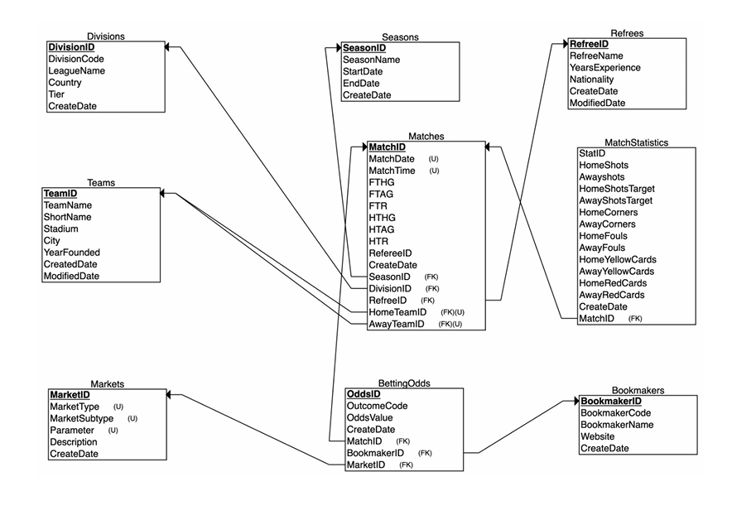
4.2 Analytical Database (OLAP)
The analytical database was built using a star schema, optimized for reporting and trend analysis. It includes multiple fact tables and dimension tables to enable slicing and dicing of data across time, location, referee, and team performance.
Fact Tables:
- fact_MatchResult
- fact_TeamMatchStats
- fact_LeagueSnapshot
Dimension Tables:
- dim_Time
- dim_Team
- dim_Season
- dim_Referee
- dim_Location
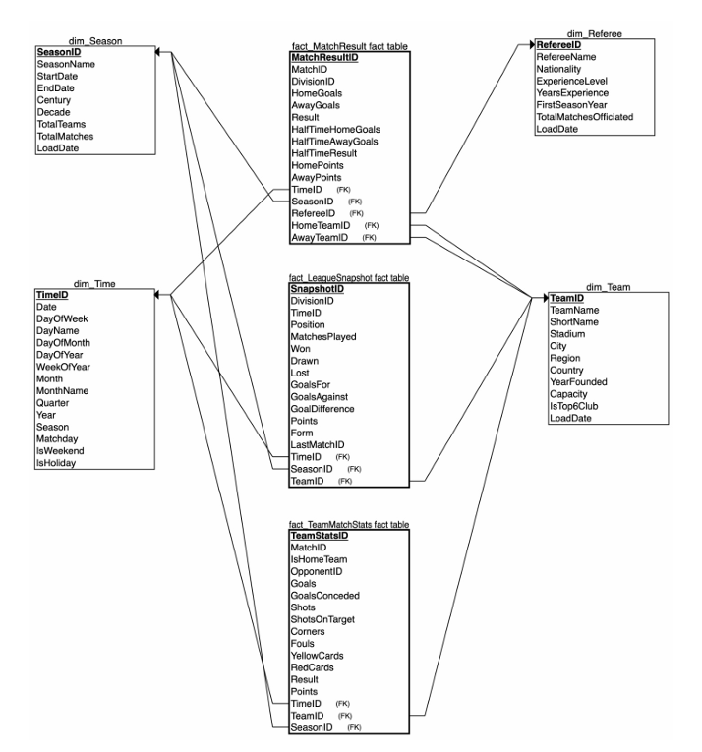

5. ETL Process
A robust Extract, Transform, Load (ETL) process forms the backbone of the Premier League Analytics System, ensuring clean, structured, and analysis-ready data flows from the source CSVs into both OLTP and OLAP databases.
The ETL was implemented using Python, leveraging libraries such as pandas, NumPy, and MySQL-connector-python for efficient data processing and SQL interaction.
5.1 Extraction
- Reads 10 seasonal CSV files sourced from football-data.co.uk
- Parses key fields: match metadata, team names, referees, scores, and odds
- Logs file metadata to ensure completeness and traceability
5.2 Transformation
- Cleaning: Handles missing values, invalid types, and standardizes categorical fields (e.g., referee names, team IDs)
- Derivation: Computes additional fields like goal difference, total cards, and aggregated odds
- Mapping: Resolves foreign key relationships to dimension tables (e.g., teams, referees, seasons)
5.3 Loading
- Loads the cleaned and validated data into the OLTP database, populating:
  - Matches, MatchStatistics, Bookmakers, BettingOdds
  - Lookup tables like Teams, Seasons, Referees, etc.
- A stored procedure (refresh_dwh_prc) is used to populate the OLAP database from the OLTP, executing steps like:
  - Truncating and reloading fact/dimension tables
  - Joining operational tables to derive analytical facts
  - Maintaining surrogate keys and ensuring dimension conformance
5.4 Automation & Reusability
- ETL notebooks and scripts are modular, supporting batch reprocessing
- The pipeline is resilient to schema drift due to pre-validation of headers and data types
5.5 Implementation Workflow & User Journey
The system follows a specific implementation sequence that combines automated setup with user-driven operations:
Phase 1: Initial Setup (Jupyter Notebooks)
- Execute 01_Sch_Squ_OPT_DB_Setup.ipynb to create the operational database schema
- Run analytical database setup notebooks (02_setup_analytical_db.ipynb through 05_etl_update_job.ipynb)
Phase 2: Operational Usage (GUI Application)
- Launch main.py to start the PyQt5 GUI application
- Login with credentials (Username: Admin, Password: admin)
- Navigate to Views → ETL Control to access the data upload interface
- Upload CSV files through the staging interface, which automatically triggers data validation and loading
Phase 3: Analytics & Reporting (Hybrid Approach)
- GUI-based Analytics: Interactive dashboards for team trends, referee analysis, and betting odds evaluation
- Notebook-based Analytics: Advanced statistical analysis and custom visualizations
Critical Integration Point: The GUI's ETL Control module serves as the primary interface for ongoing data operations, while notebooks provide the foundation and advanced analytical capabilities.
6. Operational Module
The Operational Module of the Premier League Analytics System manages structured transactional data related to football matches, including team performance, referee assignments, and betting odds. It ensures data accuracy through strict normalization and supports real-time insertion and updates.
6.1 Core Functionalities
The OLTP schema supports the following key operations:
- Match Management: Insertion of match metadata, including home/away teams, scores, dates, and referees
- Team & Referee Records: Auto-mapped foreign keys for teams and referees ensure consistency across seasons
- Season & Division Mapping: Each match is linked to a specific season and division, enabling year-wise analysis
- Match Statistics: Detailed metrics like goals, shots, fouls, possession, and cards are stored in MatchStatistics
- Betting Odds Integration: Odds from multiple bookmakers are stored per match via the Bookmakers, Markets, and BettingOdds tables, allowing comparative analytics
Referential integrity is maintained via primary/foreign key constraints, and transactional accuracy is ensured using batch commits during data loads.

6.2 Graphical User Interface (GUI) - Primary Operational Interface
The PyQt5-based GUI serves as the central hub for system operations, bridging the gap between technical database setup and user-friendly data management.
Authentication & Access Control:
- Secure login system (Default credentials: Admin/admin)
- Role-based access to different system components
Core GUI Modules:
- ETL Control Panel (Primary Feature):
  - CSV file upload and validation
  - Staging table management
  - Real-time ETL job monitoring
  - Data quality reporting
- Analytics Dashboard: Interactive visualizations accessible post-ETL
- Database Management: Connection status and operational controls
Integration with Notebooks: While Jupyter notebooks handle schema creation and advanced analytics, the GUI provides the operational bridge for daily data management tasks.
7. Analytical Module
The Analytical Module is designed to extract strategic insights from historical football match data by leveraging a star schema-based OLAP database. This module supports advanced querying across multiple dimensions such as season, team, location, and referee, and is optimized for trend and performance analysis.
7.1 Analytical Schema Design
The OLAP database includes several fact and dimension tables, enabling flexible slicing and dicing of match data:
Fact Tables:
- fact_MatchResult: Contains aggregated match-level outcome data (home/away goals, results)
- fact_TeamMatchStats: Includes granular team-level performance metrics (shots, fouls, possession, etc.)
- fact_LeagueSnapshot: Periodic snapshots of league standings or KPIs by round/week
Dimension Tables:
- dim_Team: Describes each club with attributes like name, code, and division
- dim_Referee: Stores referee information and regional mapping
- dim_Season: Captures the year and associated metadata
- dim_Location: Represents the home stadium or venue for matches
- dim_Time: Supports temporal queries by day, week, month, quarter, and year
These tables are linked by surrogate keys and maintained through a stored procedure that refreshes the OLAP database using data from the operational system.
7.2 Analytical Use Cases
Managers and analysts can use the OLAP module to answer questions such as:
- How do home and away performances differ by team and season?
- Which referees are associated with the most fouls or cards?
- Which teams consistently outperform others in possession or shot accuracy?
- What are the seasonal trends in match outcomes across the league?
- Queries are executed via Jupyter Notebooks, allowing users to:
- Run predefined or custom SQL statements
- Visualize data using Python plots
- Export reports for further analysis or presentation

8. Analytical Insights
The analytical capabilities of the Premier League Analytics System are showcased through an interactive dashboard that enables exploration of team performance trends, betting odds accuracy, and bookmaker behaviour. These insights are visualized using data pulled from the OLAP schema and transformed into interpretable charts using Python and PyQt5 GUI components.

8.1 Team Trend Analysis
This use case focuses on evaluating how teams accumulate points over the course of a season, match results by round, and general consistency in performance.
Arsenal’s – Cumulative Points Tracker (2022–23): The chart below shows the cumulative points earned by Arsenal during the 2022–23 season.
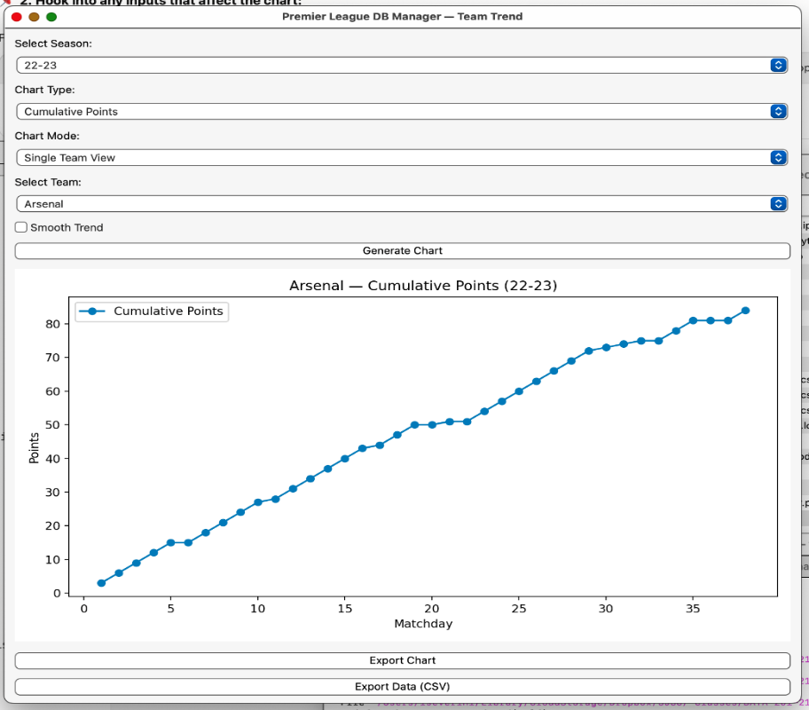
Figure 8.1: Arsenal’s match-by-match cumulative point growth
Team – Match Results (W/D/L) Overview
This chart visualizes each match result as a Win (W), Draw (D), or Loss (L) per round, providing clarity on consistency and streaks.
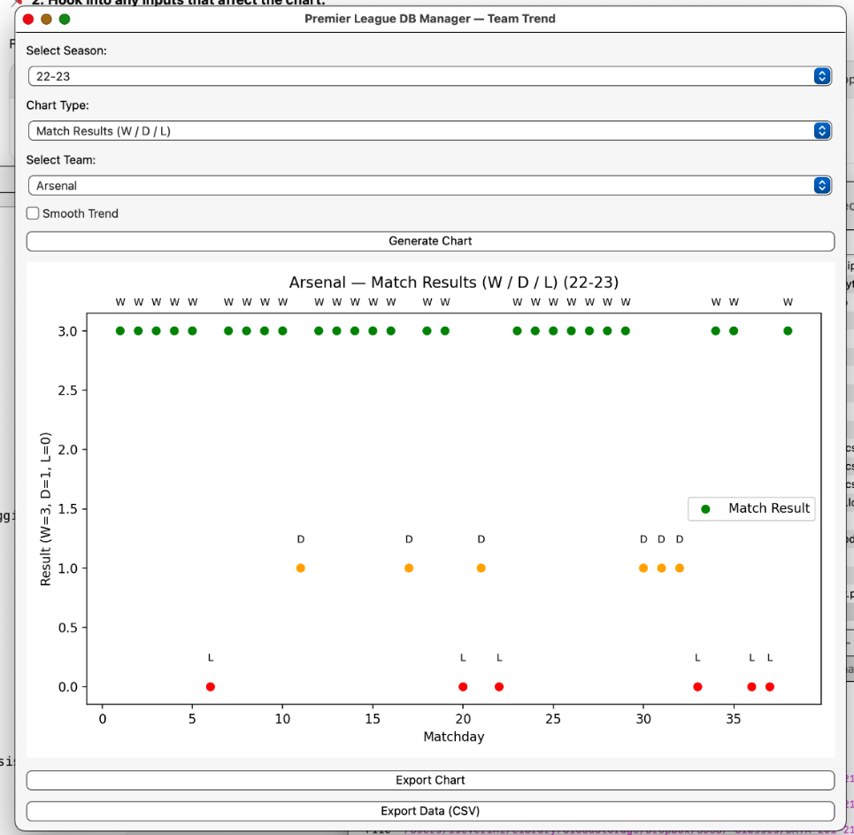
Figure 8.2: Arsenal’s 2022–23 match result trend

8.2 Odds Analysis – Bookmaker vs Reality
This set of visualizations focuses on evaluating the accuracy and margin behaviour of the bookmakers, using both implied and actual outcome data.

Implied vs Actual – Match Result Probabilities
This chart compares the probabilities implied by betting odds with the actual outcome rates across all matches.
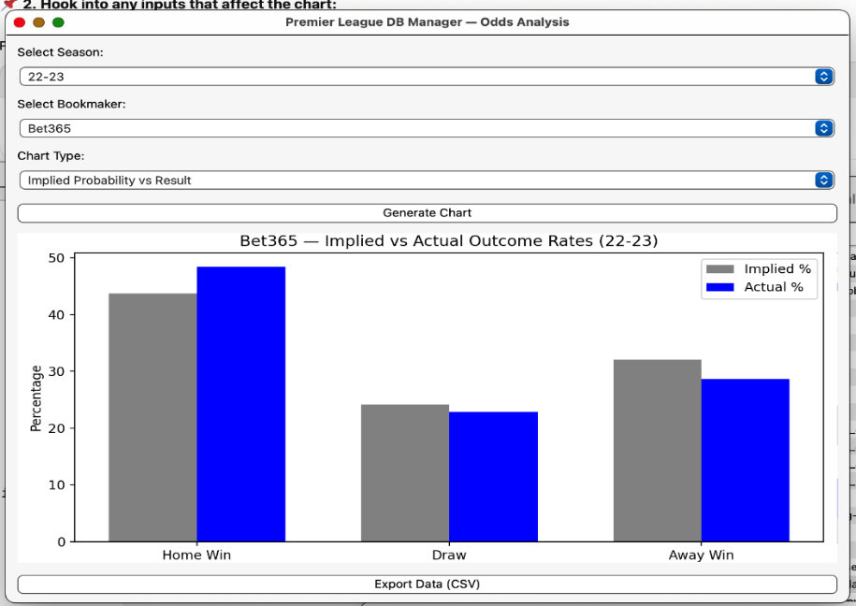
Figure 8.3: Home win, draw, and away win probabilities

Over/Under Goal Market – Implied vs Actual
This visual shows how often the bookmaker’s implied odds for “Over 2.5 goals” aligned with reality.
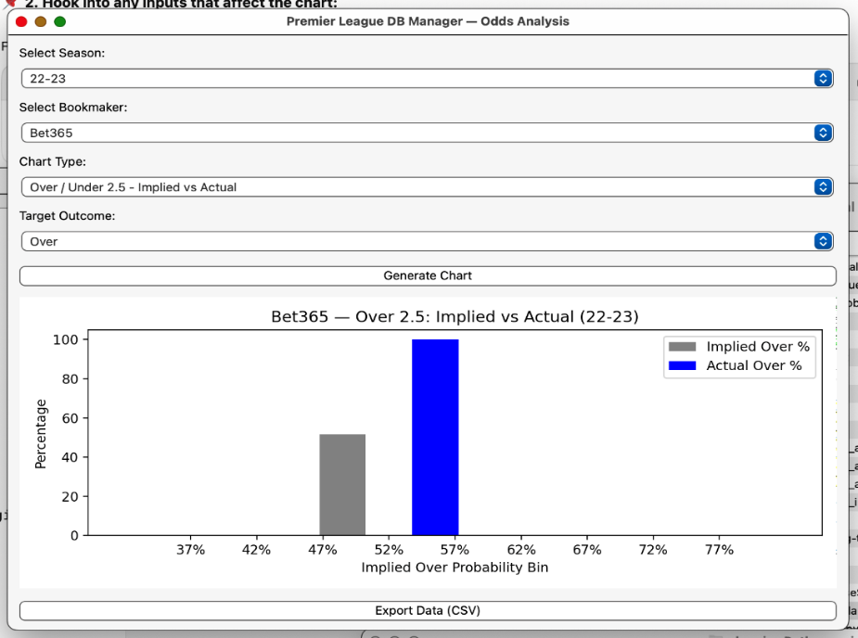
Figure 8.4: Over 2.5 Goal Line – Implied vs Actual Outcome
Bookmaker Margin Per Match
This graph illustrates the margin retained by the bookmaker on each match based on odds set, offering a lens into profitability and risk management.
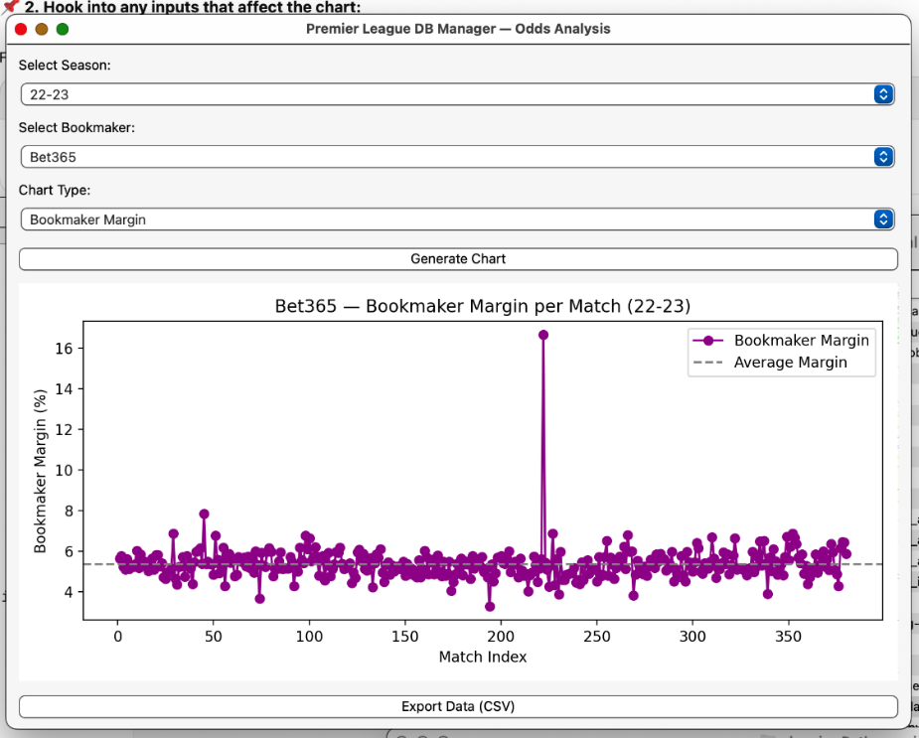
Figure 8.5: Bet365's margin spread across all fixtures
8.3 Seasonal Performance Breakdowns
- Aggregated KPIs like:
  - Points per team
  - Goal difference per Team
  - Win/loss streaks are tracked across seasons to measure league competitiveness and team consistency.
- Monthly/quarterly rollups support temporal trend analysis and anomaly detection.
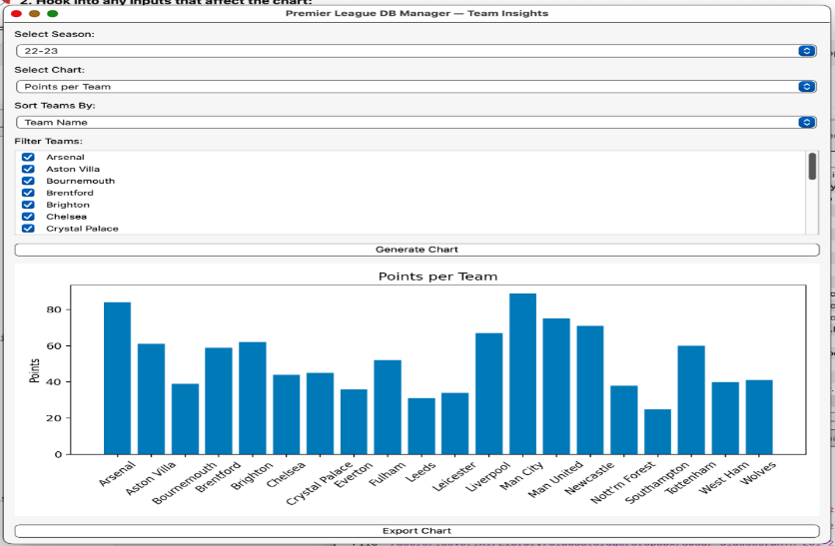
Figure 8.6: Referee match activity trend
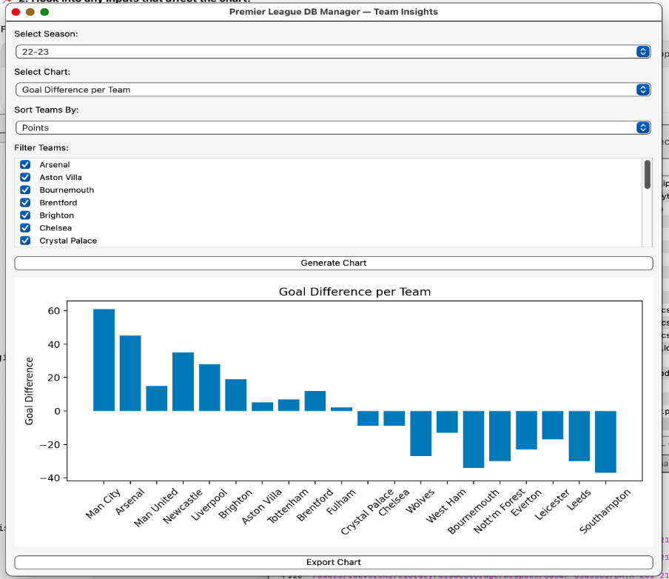
Figure 8.7: Goal Difference per team in season 22 – 23

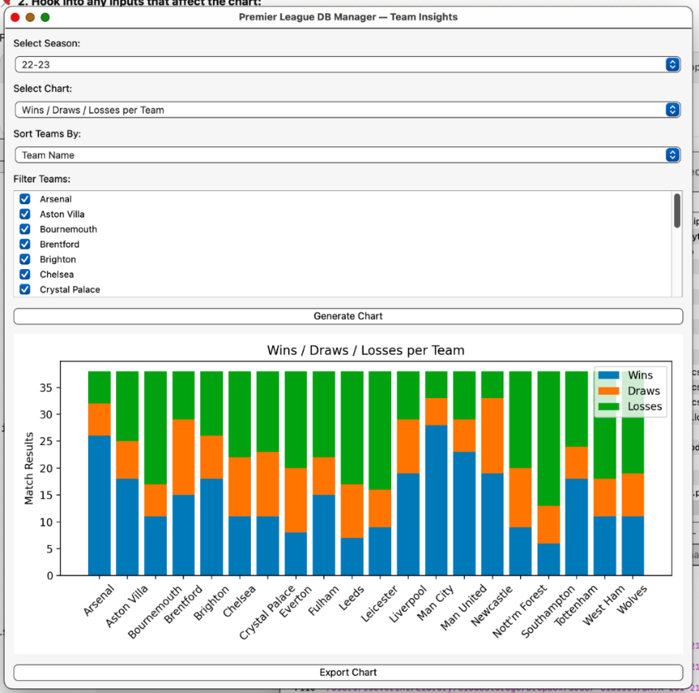
Figure 8.7: Win/Loss streaks per team in season 22 - 23
8.4 Referee Influence Analysis
Referees significantly impact the flow and discipline of football matches through their decisions on fouls and cards. This analysis focuses on tracking referee behavior using metrics such as yellow cards, red cards, and fouls across matchdays and seasons.
Data from the operational and analytical databases is used to generate trends and comparisons that highlight variations in officiating styles.By visualizing individual referee patterns and comparing them across the league, this module helps identify tendencies such as strictness.These insights enable teams to better anticipate match conditions and offer a data-driven perspective on referee consistency and performance throughout the season.
Referee Trends Over Time – D Bond (2022–23)
The following visualization illustrates the number of fouls, yellow cards, and red cards issued by referee D Bond over a rolling set of matchdays in the 2022–23 season.
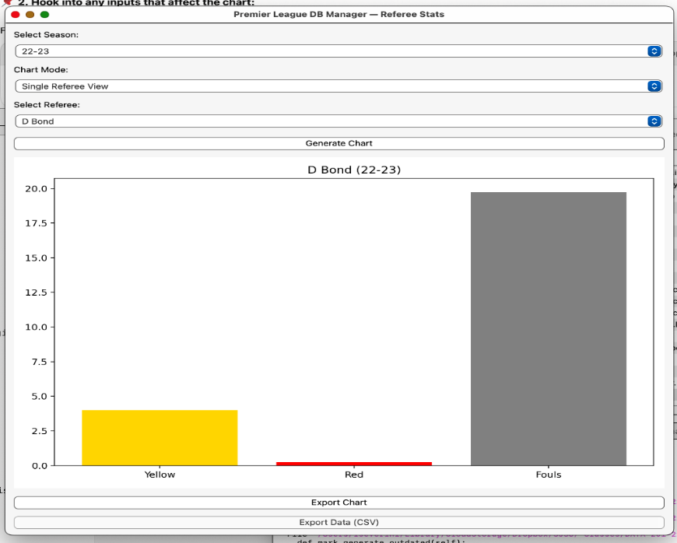
Figure 8.8: Referee match activity trend
Yellow Cards Per Referee
This chart presents an overview of yellow card issuance rates per match, helping identify stricter referees across the league.
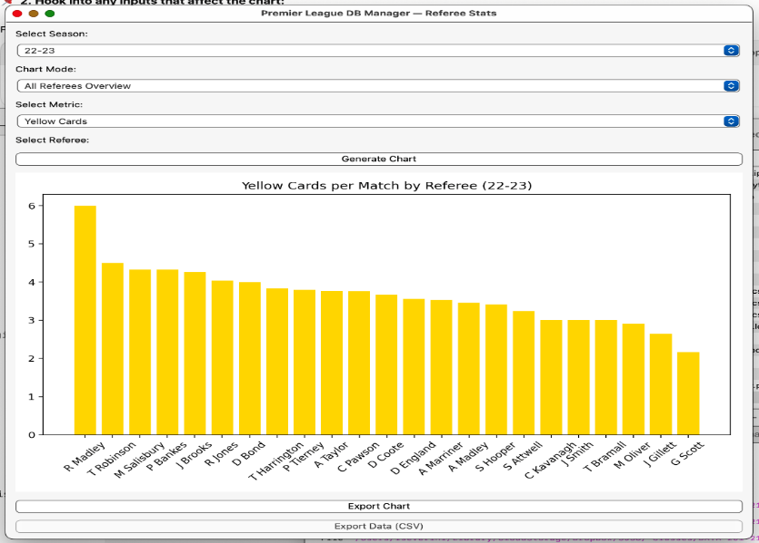
Figure 8.9: League-wide yellow cards per referee
Referee Comparison – D Bond vs A Madley
A side-by-side comparison of two referees over the season reveals differences in disciplinary style and foul frequency.
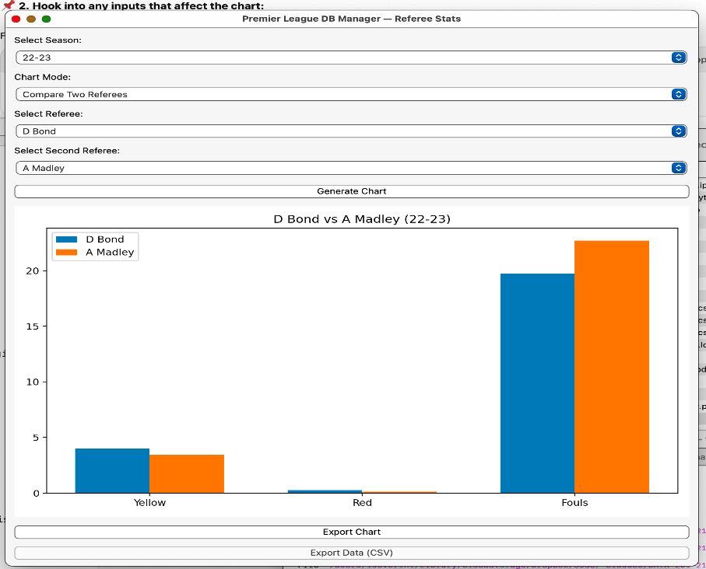
Figure 8.8: Carding and foul trend: D Bond vs A Madley
These insights are derived from pre-aggregated fact tables in the star schema and visualized using Python tools like matplotlib and seaborn. Analysts can drill down or roll up based on season, team, referee, or location to support hypothesis testing or data storytelling.
9. Technical Challenges & Solutions
During the development of the Premier League Analytics System, several technical challenges were encountered while handling raw data, designing normalized and star schemas, and ensuring ETL robustness. The following solutions were implemented to resolve these issues efficiently.
9.1 Reserved Keywords in SQL
- Challenge: Some CSV column names conflicted with MySQL reserved keywords (e.g., match, time, rank)
- Solution: All problematic identifiers were wrapped in backticks (`) in SQL queries to avoid syntax errors
9.2 Inconsistent CSV Schema Across Seasons
- Challenge: Column order, naming, and available metrics varied slightly across CSVs
- Solution: A flexible column-mapping logic was implemented in the ETL script to:
  - Normalize column names
  - Add default values for missing metrics
  - Skip irrelevant or inconsistent fields safely
9.3 Referential Integrity & Foreign Key Conflicts
- Challenge: Loading data into the operational database caused integrity errors when referenced dimension data (e.g., teams, referees) was missing
- Solution: Dimension tables (Teams, Referees, etc.) were preloaded and validated before inserting transactional records. ETL scripts included fallback ID lookups and logging of unmatched references

9.4 OLAP Star Schema Loading Performance
- Challenge: Populating OLAP fact tables from OLTP caused slowdowns during large batch loads
- Solution:
  - Created a stored procedure (refresh_dwh_prc) to truncate and reload OLAP tables atomically
  - Indexed surrogate keys and fact relationships
  - Used pre-joins and aggregated selects to minimize transformation steps during load

9.5 Betting Data Integration
- Challenge: Bookmaker odds data varied in completeness and format across matches
- Solution:
  - Created normalized structures for Bookmakers, Markets, and BettingOdds
  - Used conditional inserts to only store valid odds
  - Implemented fallback logic when markets were missing

These strategies ensured that the system remains robust, extensible, and efficient even when working with complex historical datasets and dynamic analytical requirements.

10. Technical Aspects
The following is the list of the files used in the application:

Implementation Note: Hybrid Architecture
🔧 CRITICAL IMPLEMENTATION SEQUENCE:
1. Notebooks: Database schema setup (OLTP & OLAP)
2. GUI (main.py): Operational data management & ETL
3. Notebooks + GUI: Analytics and reporting

The GUI's ETL Control module is the PRIMARY interface for ongoing
data operations, making the system accessible to non-technical users
while maintaining the analytical power of Jupyter notebooks.

Operational Module
S.No | File Name | Type | Description
1 | Sch_Squ_OPT_DB_Setup.ipynb | Jupyter NB | Creates the schema for the operational (OLTP) database
2 | Folder: pl_gui | Python | Loads raw data into the operational database/ Anlytics Options
3 | data201.py | Python | Reusable functions for DB connection, transformation, etc.
4 | premier_league_analytics.ini | Configuration | Database connection configuration file
Analytical Module
S.No | File Name | Type | Description
5 | 2_setup_analytical_db.ipynb | Jupyter NB | Defines and creates the analytical (OLAP) schema
6 | 3_load_analytical_data.ipynb | Jupyter NB | Loads dimension and fact tables using data from OLTP
7 | 4_premier_league_analytics.ipynb | Jupyter NB | Executes analytical queries and visualizations
8 | 5_etl_update_job.ipynb | Jupyter NB | Refreshes OLAP data using the stored procedure

Documentation & Support
S. No | File Name | Type | Description
09 | Proposal.txt | Text | Initial project proposal
10 | Premier_League_Analytics_Project_Presentation.pptx | PowerPoint | Final presentation
11 | Premier_League_Analytics_Project_Presentation.pdf | PDF | Presentation PDF version
12 | RemoteDatabaseServer.pdf | PDF | Info about database server hosting
13 | README.md | Markdown | Repository instructions and overview
12. Database Technical Details
12.1. DB Objects
Database Type | Object Type | Name | Usage
Operational | Table | Teams | Metadata for clubs
Operational | Table | Seasons | Premier League seasons
Operational | Table | Referees | Match referee data
Operational | Table | Matches | Core match records
Operational | Table | MatchStatistics | Possession, shots, cards, etc.
Operational | Table | Bookmakers | List of betting operators
Operational | Table | Markets | Betting market types (Home, Draw, Away)
Operational | Table | BettingOdds | Odds values for each market and match
Analytical | Table | dim_Team | Dimension table for team details
Analytical | Table | dim_Season | Year-wise dimension
Analytical | Table | dim_Referee | Referee dimension table
Analytical | Table | dim_Location | Stadium or match venue info
Analytical | Table | dim_Time | Time hierarchy dimension
Analytical | Fact Table | fact_MatchResult | Aggregated result facts
Analytical | Fact Table | fact_TeamMatchStats | Performance facts per team
Analytical | Fact Table | fact_LeagueSnapshot | League position and points by round
Analytical | Stored Proc | refresh_dwh_prc | Refreshes OLAP DB with data from OLTP

12.2. ETL
The ETL process is driven by Jupyter notebooks and Python scripts to ingest and transform seasonal match data.
- Operational:
Files from football-data.co.uk are loaded into the OLTP schema. Data is normalized, and foreign keys (teams, referees, seasons) are validated during insertion.
- Analytical:
A stored procedure named refresh_dwh_prc truncates OLAP fact/dimension tables and repopulates them using aggregated joins across the OLTP tables. Time dimension is derived from match dates.

13. Queries (Operational DB)
Purpose | Query
Match Info | SELECT * FROM Matches WHERE match_id = 1024;
List Teams | SELECT team_id, team_name FROM Teams;
Odds for a Match | SELECT b.name, m.type, o.home_odds, o.draw_odds, o.away_odds FROM BettingOdds o JOIN Bookmakers b ON o.bookmaker_id = b.bookmaker_id JOIN Markets m ON o.market_id = m.market_id WHERE o.match_id = 1024;
Match Statistics | SELECT * FROM MatchStatistics WHERE match_id = 1024;

14. Queries (Analytical DB)
Purpose | Query
Top 10 Goal-Scoring Teams | SELECT t.name, SUM(m.home_goals + m.away_goals) AS total_goals FROM fact_MatchResult m JOIN dim_Team t ON m.team_id = t.team_id GROUP BY t.name ORDER BY total_goals DESC LIMIT 10;
Average Possession by Season | SELECT s.year, AVG(ts.possession_home) AS avg_possession FROM fact_TeamMatchStats ts JOIN dim_Season s ON ts.season_id = s.season_id GROUP BY s.year;
Referee Card Average | SELECT r.name, AVG(ts.cards) AS avg_cards FROM fact_TeamMatchStats ts JOIN dim_Referee r ON ts.referee_id = r.referee_id GROUP BY r.name ORDER BY avg_cards DESC;

15. Conclusion
The Premier League Analytics System is a comprehensive solution integrating normalized transactional processing with analytical reporting capabilities tailored for football data. Through effective use of Python, MySQL, PyQt5, and Jupyter, the project successfully achieved the following:
- Built a dual-database model with OLTP and OLAP components
- Extracted and normalized over a decade of Premier League data
- Integrated betting odds alongside match performance data
- Enabled advanced visual and SQL-based analytics using a star schema
- Delivered a modular and extensible framework with GUI and ETL
Hybrid Implementation Success: A key achievement of this project is the successful integration of Jupyter notebooks for technical setup with a user-friendly GUI for operational management. This hybrid approach ensures that technical users can leverage the full power of Python and SQL for complex analytics, while operational users have an intuitive interface for daily data management tasks. The GUI's ETL Control module particularly demonstrates how complex data engineering processes can be made accessible through thoughtful interface design.
This project highlights strong competencies in database design, data engineering, and sports analytics — translating classroom concepts into a real-world solution that can support club decision-makers, analysts, and fans alike.

